**Name: Nada Ragab Mohamed.**

**Topic: Artificial Intelligence.**

**B.N:986**

**Applications Brief: In computer science, in contrast to the natural intelligence displayed by humans and animals, artificial intelligence ( AI), also called machine intelligence, is intelligence exhibited by machinery. Leading AI textbooks define the field as the study of "intelligent agents": any device perceiving its environment and taking action that maximizes its chance to achieve its goals successfully. Colloquially, the term "artificial intelligence" is also used to describe machines (or computers) that imitate "cognitive" functions that people associate with the human mind, such as thinking and problem solving. Approaches include statistical, computational, and traditional symbolic AI methods. Many tools are used in AI including search and mathematical optimization versions, artificial neural networks, and statistical, probability, and economic-based methods. The area of AI draws on computer science , information processing, physics, psychology , linguistics, philosophy, and many other areas.**

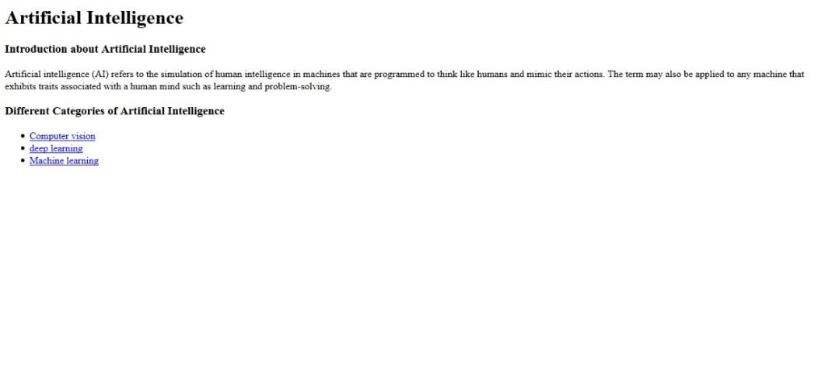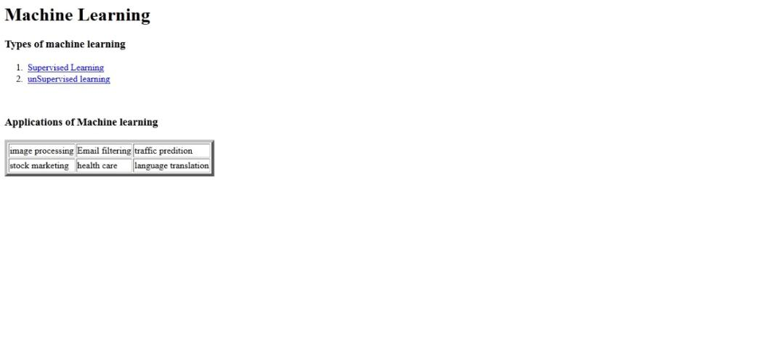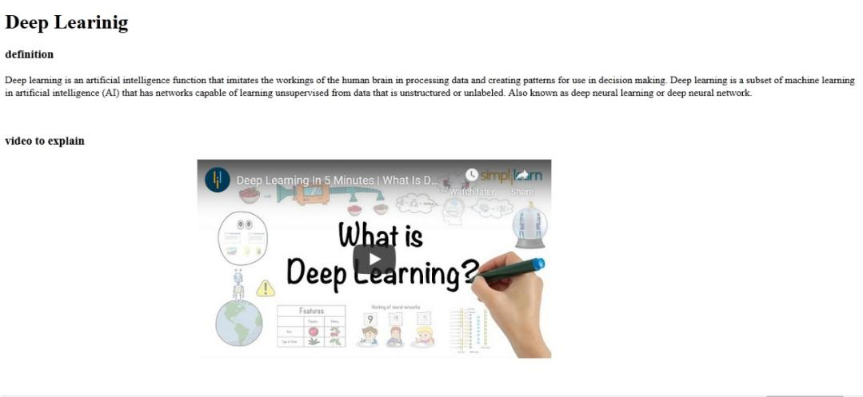**Screenshots:.**

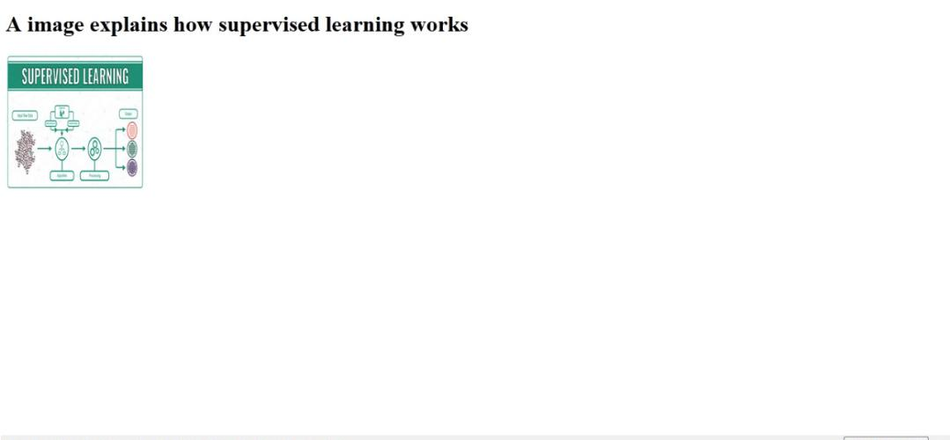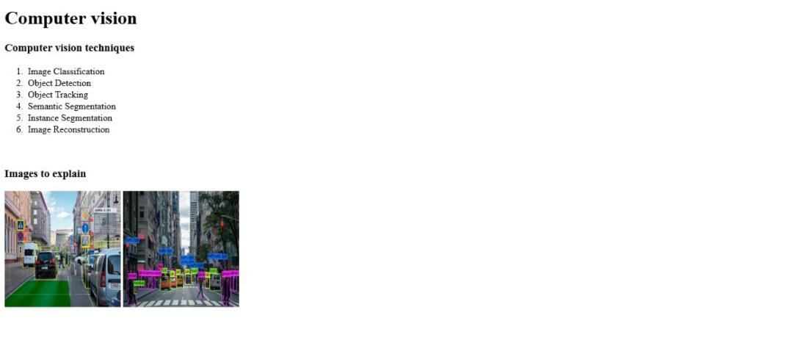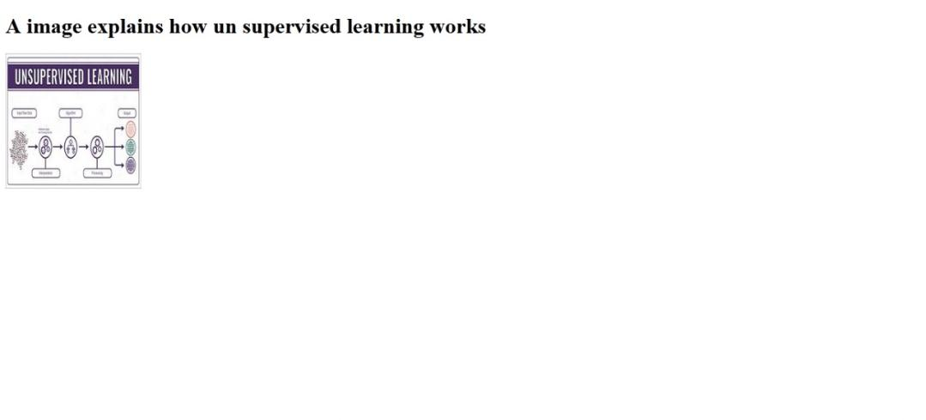

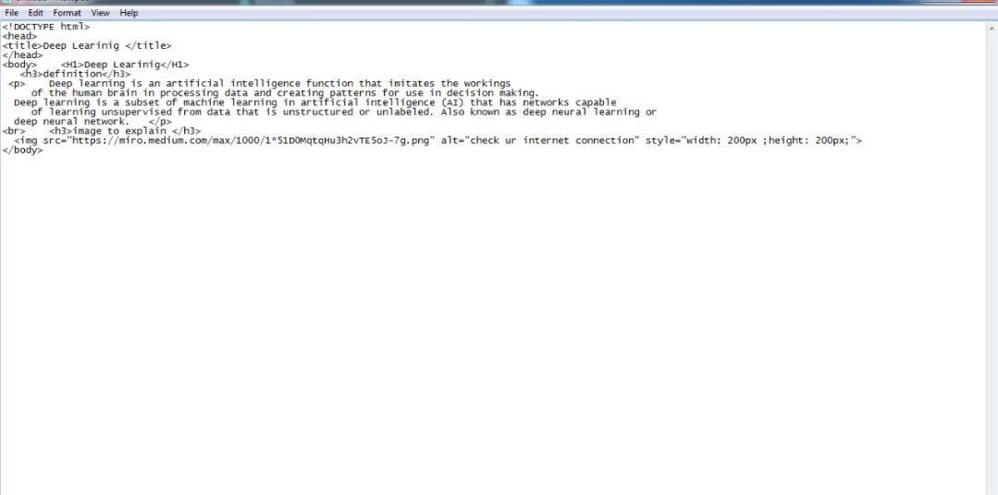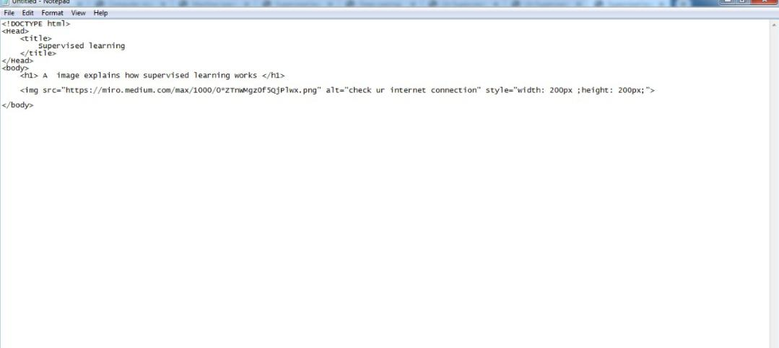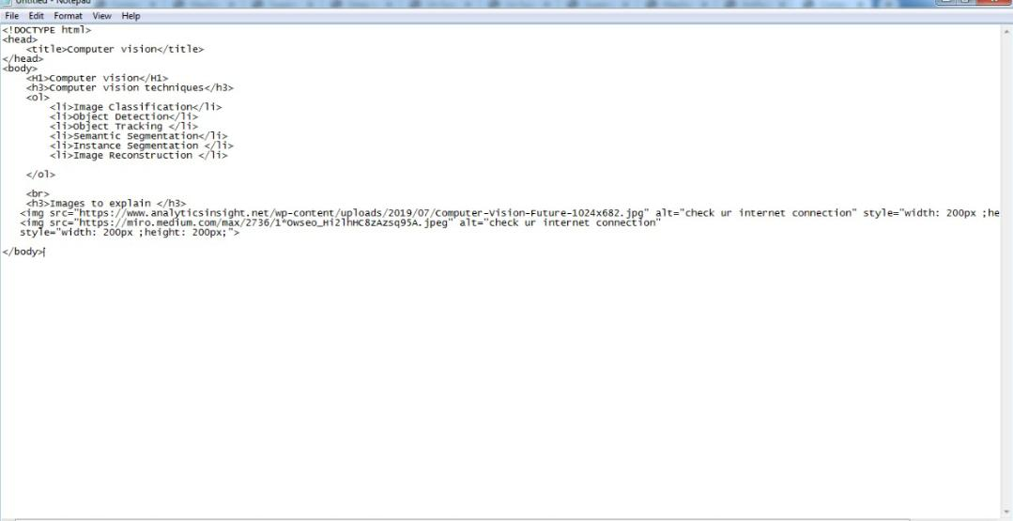**Source code:**

